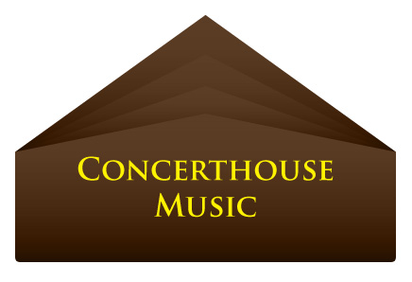

PRESS RELEASE - EFFECTIVE IMMEDIATELY – 10 August 2012

DAVID JULIET’S WEBSITE GETS A FACE-LIFT.

Concerthouse Music artist, David Juliet’s Official Website has recently gotten a face-lift! Make sure to check out the latest design pieced together by the Magic Blue Creative team. We are proud of the update and believe that this, alongside our media marketing and networking, will help take David’s career as an artist to the next level.

Over the past two years, David Juliet has been busy promoting his debut “Variations” – a carefree, easy listening album that has gathered quite a lot of positive attention.

We are proud of David for his previous nominations for the New Artist of the Year Award in New Music Weekly Magazine and Best Male Mainstream Artist and Favourite International Mainstream Artist by the Independent Music Network.

Inspired by performers from a young age, David Juliet knew that this was something he had to do. Picking up a guitar at the age of eleven and writing his first songs in his teens, bands quickly followed, for which he sang and wrote the material.

Needing a new path away and apart from the egos and opinions that are a part of any band setting, David Juliet continued writing, selected a number of songs, booked some studio time, hired musicians and made a record.

Recording the music exactly as he wanted to record it, Juliet came out of the studio with Variations: a precise rendering of his vision. “With his strong vocal, catchy hooks, and powerful colourful lyrics” (Isaac Davis Jr.) you get uncompromised music from the heart and soul of a man who is nothing else but the music he makes.

To see what all the fuss is about, check out his album on iTunes, you won’t be disappointed: http://itunes.apple.com/au/album/variations/id466792200

For more information on David Juliet, you can visit his Official Website at: www.davidjuliet.com

************************************************************************

ABOUT CONCERTHOUSE MUSIC:
www.concerthousemusic.com
Concerthouse Music is a label that works to ensure the development and nurturing of its artists business models through its ability to provide connectivity to over 600 digital retail stores and over 100 mobile platforms and operators.

With a specialized focus on marketing strategy, lives performance, touring advising and support infrastructure for their artists, CEO Ross Tonkin and his team, work to develop a unique program suited to each of their talented musicians.

Concerthouse artists include: Jessy Tomsko, Paul Cresey, Kara Mack, Earth and the Next Society, and David Juliet

Search “Concerthouse Music” on Google for more information.

************************************************************************

Contact Details:

Media and Press Manager

Concerthouse Music
Unit 20 No 112 McEvoy Street
Alexandria NSW 2015
P: + 61 2 9310 0155
F: + 61 2 9310 0166
E: pr@bluepie.com.au
W: www.concerthousemusic.com/

Concerthouse Music is a Blue Pie Productions and Blue Pie Label partner and distributed by Blue Pie for the world.
************************************************************************

